Input and Output Screenshots for Week 2 Citi Bike Example

Wade Eckert
Bellevue University
DSC 350: Data Wrangling for Data Science
Dr. David Kinney
June 15, 2025

Input and Output Screenshots for Week 2 Citi Bike Example

Input code, comments, and documentation:
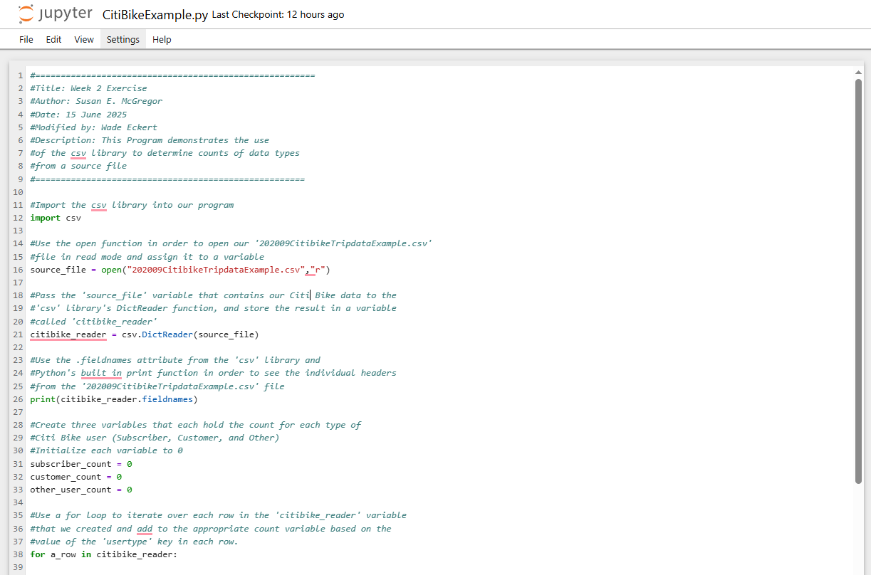
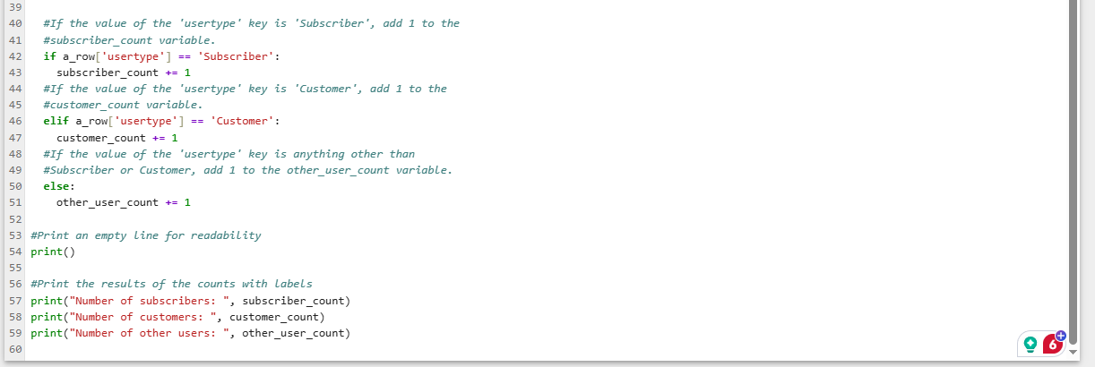

Output of code:
